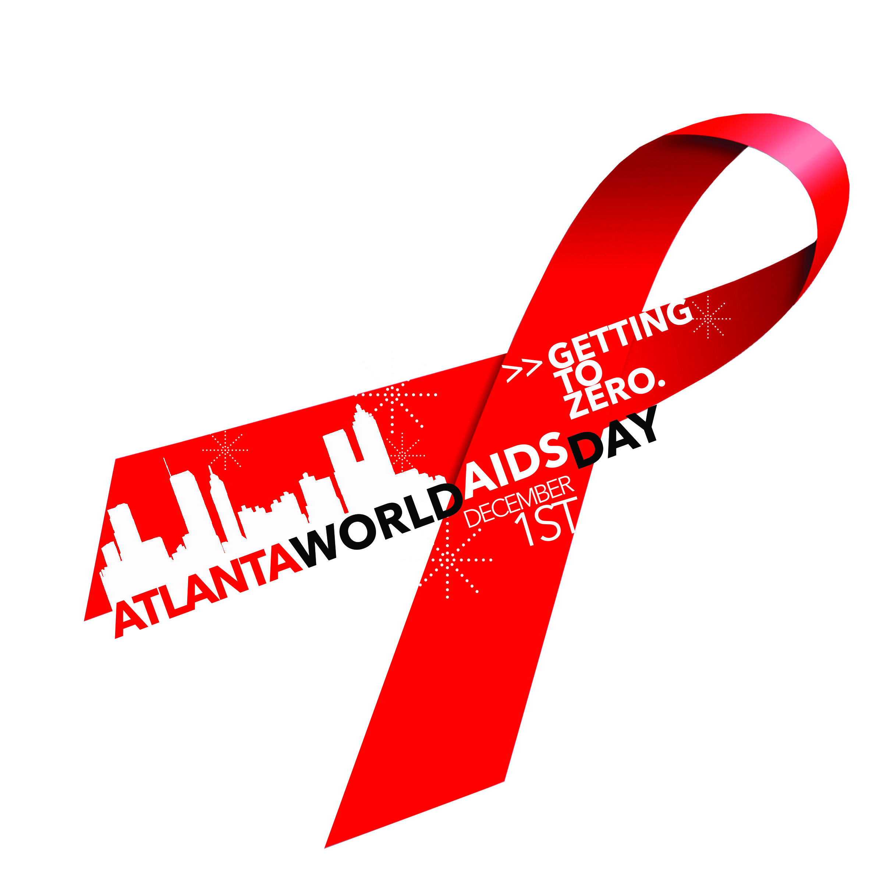
World AIDS Day-Atlanta Policy & Action Breakfast

We have known for quite some time that Georgia has been hard hit by the AIDS epidemic with well over 50,000 people known to be living with HIV/AIDS and the fifth highest HIV infection rate in the country. However, we are only now beginning to understand Atlanta is in the heart of the United States’ HIV epidemic. Youth, in particular, remain at high risk for contracting the virus. Over the past 5 years, over 4,400 youth were diagnosed in Metro Atlanta, and only 1/3 are receiving the care needed to stay healthy and prevent transmission. Researchers suspect that low rates of testing, lack of HIV and sexuality education, high rates of homelessness and poor healthcare access contribute to Atlanta youth’s HIV risk. Activists are calling for commitment from public health and political leaders to address the growing problem of HIV among young people.

HIV & YOUTH IN METRO ATLANTA: WHAT LEADERS CAN DO

SCHOOLS
Schools are vital resources in the fight against HIV. We are asking district and school leaders in Metro Atlanta to take the following measures toward building an AIDS-Free Generation:

Support implementation of comprehensive sex education
To protect themselves from HIV and STDs and prevent unplanned pregnancy, young people deserve a comprehensive, medically accurate sexual health curriculum that is proven to be effective at reducing risk behavior and encouraging healthy relationships.

Abstinence-only sex education is ineffective.
Georgia state law requires all districts to offer sex and HIV education. Contrary to popular belief, districts are not limited to abstinence-only sex ed, and may lawfully implement comprehensive sex education, which may stress abstinence but also includes information on contraception, HIV/STD prevention and healthy relationships. Numerous studies show comprehensive sex education is better than the abstinence-only approach at reducing HIV risk behaviors.

All sex education should be LGBTQ-inclusive.
Effective comprehensive sex education should include the behaviors and identities of LGBTQ students. Without acknowledgement of LGBTQ identities and same-sex sexual behavior, reducing HIV risk among youth will be impossible.

Make schools safe schools for LGBTQ students
LGBTQ students experience frequent bullying and harassment based on sexual orientation and/or gender identity. LGBTQ students are likelier than their non-LGBTQ peers to suffer from depression and attempt suicide. Depression is linked to behaviors that place LGBTQ youth at disproportionate risk for HIV.

Encourage students who want to create Gay-Straight Alliances (GSAs)
The presence of a gay-straight alliance (GSA) inside a school has been shown to reduce bullying and associated risk of depression and suicide for LGBTQ students. Students and staff advisors should be encouraged and supported in their efforts to create a GSA. Information about how to help students build GSAs can be found at GLSEN.org.

Designate Safe Space in your school
Fulton, Dekalb and Atlanta city school districts all have anti-bullying policies in place that address sexual orientation and gender identity. This is an important first step in creating safe space for LGBTQ students. In the school itself, staff allies may designate “safe space” in their classroom, counseling office or other area where LGBTQ students will be welcomed as they are, affirmed and connected to resources that meet their needs. This safe space could be designated by LGBTQ-affirming symbols or literature. GLSEN.org provides a safe space kit for schools.

Train staff in LGBTQ cultural competency at least once per year
In order to create genuinely safe spaces at schools, teachers, counselors, administration, nurses and parent liaisons should be trained at least annually to competently interface with LGBTQ students. Staff should be prepared to address bullying based on sexual orientation and gender identity and connect LGBTQ students with appropriate resources. The Georgia Safe Schools Coalition offers these trainings free of charge.

HEALTHCARE
Youth must be empowered with quality, affordable health insurance options, and must have ready access to information about these options. To achieve an AIDS-Free Generation for Atlanta, we ask the following from elected officials and healthcare policymakers:

Expand minors’ access to confidential HIV and sexual health services.
Georgia is one of 18 states that allows a doctor to inform a minor's parent if the minor receives testing or treatment for STDs and HIV. Under this scenario, although a doctor is not required to inform a minor’s parents, the doctor has discretion to decide whether to disclose this information. This may create barriers to HIV testing and treatment.
Youth-friendly clinical services must ensure confidentiality. While minors do not have legal capacity to consent to medical treatment, there are certain exceptions to this rule. Sexual health services, such as STD testing and treatment, may occur without parental consent. Medical staff at clinics and hospitals should be trained to be sensitive to confidentiality and should be trained to deal with the unique sexual health needs of young people and LGBTQ people.

Expand Medicaid.
The ACA was enacted in 2010, but the U.S. Supreme Court’s decision in National Federation of Independent Business v. Sebelius (2012) affirmed the right of states to decline to expand the pool of people eligible for health insurance under the Medicaid program. Medicaid expansion would extend coverage to people living with incomes at 133% of the federal poverty line. Expansion of Medicaid in Georgia would, therefore, have a tremendous effect on reaching more young people and ultimately improving sexual health outcomes for youth living with HIV or at risk of acquiring HIV.

Make routine, opt-out HIV testing available throughout Atlanta.
The US Centers for Disease Control and Prevention (CDC) recommended in 2006 that all patients 13-64 routinely receive HIV tests during healthcare visits unless they opt out. Up to 60% of young people living with HIV are unaware of their HIV status, and young people are less likely than older people to be tested for HIV. Thus, routine, opt-out HIV screening could have a tremendous impact on identifying young people living with HIV and engaging them in medical care.

Make Pre-Exposure Prophylaxis (PrEP) available and accessible.
Pre-exposure prophylaxis (commonly known as “PrEP”) is a cutting edge HIV prevention method that decreases an individual’s risk of acquiring HIV. The U.S. Food and Drug Administration approved it for consumption in July 2012. PrEP is marketed under the brand name “Truvada,” and contains two drugs used in HIV treatment. When taken once daily for a consistent period of time, PrEP has been shown to reduce HIV acquisition risk up to 92%. PrEP’s effectiveness increases when combined with other safe sex methods such as male or female condoms. Young people need access to this potentially life-saving medication.

HOUSING
Homelessness is a risk factor for HIV among youth in Atlanta, and many people living with HIV experience homelessness. We will not build an AIDS-Free Generation for Atlanta without addressing youth homelessness. We ask the following from elected officials and community leaders:

Count Atlanta’s homeless youth.
Unlike homeless adults, homeless youth and teens are unlikely to be found living on the streets. Homeless youth are likely to reside in abandoned buildings or other out-of-the-way places or they may engage in “couch surfing” between friends’ homes. This means that youth and teens are often left out of cities’ homeless census (or “point-in-time” count). Without an accurate count of homeless youth in Metro Atlanta, we are unable to fund and provide services reflective of their need. We encourage city and county HUD entities to utilize counting methodology that includes young people who would otherwise be uncounted.

Implement shelter non-discrimination policies that include sexual orientation and gender identity
It is estimated nationwide that 40% of homeless youth identify as LGBTQ. LGBTQ youth are at a heightened risk for discrimination and violence while staying in shelters, both from staff members and other clients. Many shelters are highly gendered environments that are difficult for transgender residents. It is essential that homeless shelters create non-discrimination policies in line with Atlanta city law banning discrimination based on sexual orientation and gender identity.

Train shelter staff in LGBTQ cultural competency at least once per year.
To bolster policies banning discrimination based on sexual orientation and gender identity, staff should be trained at least once per year on cultural competency specific to LGBTQ residents. Given their likelihood of encountering LGBTQ youth, homeless shelter staff should be prepared to house LGBTQ residents and ensure their safety and wellbeing while sheltered.

